# [**Christopher Meloni Previews Law & Order Comeback, Confirms Long-Awaited Benson/Stabler Reunion**](https://tvline.com/2020/07/07/law-and-order-svu-benson-stabler-reunion-christopher-meloni/)

By [Kimberly Roots](https://tvline.com/author/kimberly-roots/) / July 7 2020, 7:53 AM PDT



Courtesy of NBC

[*Law & Order: SVU*](https://tvline.com/tag/law-order-svu/) fans aren’t the only ones who’ve been thinking long and hard about getting Olivia Benson and Elliot Stabler back onto each other’s beat.

*SVU* vet [Christopher Meloni](https://tvline.com/tag/christopher-meloni/), who will return to the *Law & Order* franchise this fall in a Stabler-centric new series subtitled *Organized Crime*, says that the [previously teased reunion](https://tvline.com/2020/05/01/law-and-order-svu-stabler-season-22-premiere-christopher-meloni/) between his character and Mariska Hargitay’s Benson “just has to be.”

“Benson and Stabler are inextricably linked, locked and connected,” he says in a new interview with the [*New York Post*](https://nypost.com/2020/07/06/christopher-meloni-on-returning-to-the-law-order-universe/). “I think there is truly and deeply a worthwhile, inherent drama in exploring that relationship and the complexity of how Stabler left — the unresolved emotions both characters feel and how the fans feel.”

[**2020 Fall TV Preview: Guide to All the New Comedies and Dramas**](https://tvline.com/gallery/fall-new-tv-shows-preview-photos-2020/?ref=https://tvline.com/2020/07/07/law-and-order-svu-benson-stabler-reunion-christopher-meloni/)

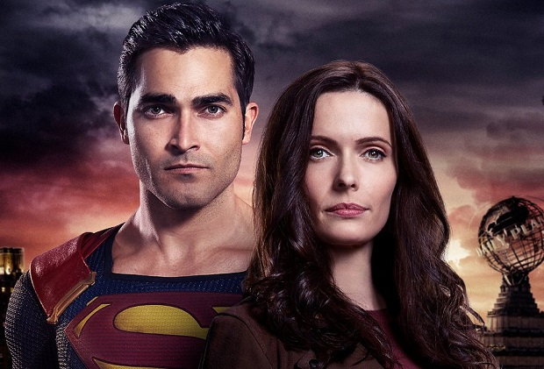

[**Launch Gallery**](https://tvline.com/gallery/fall-new-tv-shows-preview-photos-2020/?ref=https://tvline.com/2020/07/07/law-and-order-svu-benson-stabler-reunion-christopher-meloni/)

Meloni departed *SVU* after negotiations related to his contract broke down at the end of Season 12. When Season 13 started, Stabler had retired from the police force without saying anything to his tight-knit co-workers; his partner, Olivia Benson, learned the devastating news at the same time as the audience did.

“How my character left was really unsatisfying, I think,” he says, adding that the possibility exists of shooting multiple *SVU*–*Organized Crime* crossover episodes. “People will always be hungry to see how we interact and how that dynamic has changed.”

NBC ordered *Organized Crime* to series in March; production has since halted due to the COVID-19 shutdown. The spinoff is slated to air Thursdays at 10/9c in the fall and, per the official logline, will follow Meloni’s character as he “returns to the NYPD to battle organized crime after a devastating personal loss.”

Though he declines to detail exactly what that loss entails, Meloni says that *Law & Order* boss Dick Wolf has given him a general idea of the world Stabler will inhabit in the new series, as well as “what brings him back into the fold and where he’s been.”